

SE3082
Parallel Computing
3rd Year, 1st Semester

Assignment 3 (Individual)
IT23223394
Submitted to
Sri Lanka Institute of Information Technology

1st December 2025

Documentation and Analysis
2.1 Parallelization Strategies
OpenMP:
Parallelized the outer loop using #pragma omp parallel for.
Threads share matrices in memory; private loop indices used to avoid race conditions.
No explicit load balancing; each thread roughly processes N/threads rows.
MPI:
Data partitioned row-wise across processes using MPI_Scatter.
Each process computes its local rows, then results can be gathered (though not implemented in timing).
Load balancing is static and uniform.
CUDA:
Each matrix element is computed by one GPU thread.
Threads organized in blocks; blocks form a grid.
Memory transfers between host and device managed explicitly.

2.2 Runtime Configurations
Hardware
- CPU: Intel Xeon CPU @ 2.20 GHz, 1 core / 2 threads, x86_64 architecture
- RAM: 12 GiB total, 9.2 GiB free during tests
- GPU: NVIDIA Tesla T4, 15 GB total memory, 14.64 GB available for CUDA
- GPU Utilization: Idle (0%) during runtime, ensuring full availability for computation
- Other Hardware Info: Single socket, 2 logical CPUs online, L1/L2/L3 caches: 32 KiB / 256 KiB / 55 MiB
Software
- Operating System: Ubuntu 20.04 LTS
- Compilers:
GCC (for C/OpenMP/MPI): 11.4.0 (Ubuntu 11.4.0-1ubuntu1~22.04.2)
NVCC (for CUDA): 12.5 (V12.5.82, Build cuda_12.5.r12.5/compiler.34385749_0)
- CUDA Driver: 12.4 (NVIDIA-SMI)
- Libraries/Frameworks:
OpenMP
MPI (via GCC)
CUDA Runtime API
Notes
CPU has only 1 core with 2 threads, which explains why OpenMP scaling is limited.
GPU memory is more than sufficient for all tested matrix sizes (up to 2048×2048).
Minor version difference between NVCC (12.5) and CUDA driver (12.4) is normal and does not affect code execution.

- Parameters:
OpenMP: 1, 2, 4, 8 threads
MPI: 1, 2, 4, 8 processes
CUDA: Block sizes 8×8, 16×16, 32×32; matrix 800×800
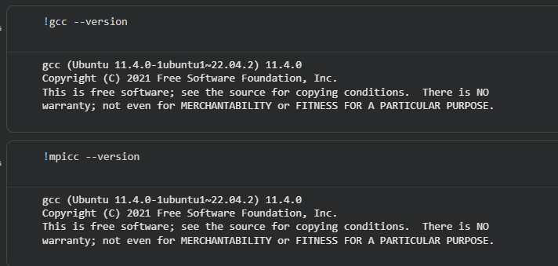
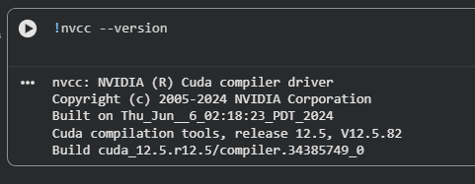
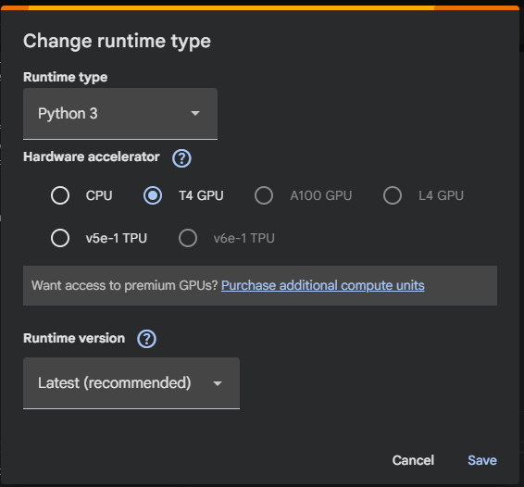
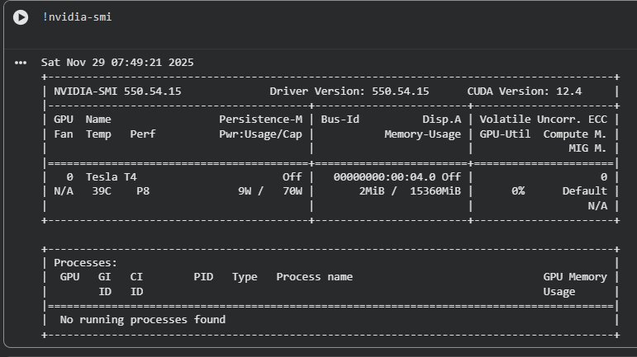
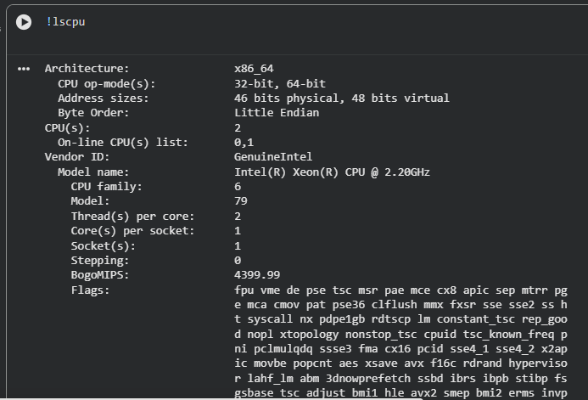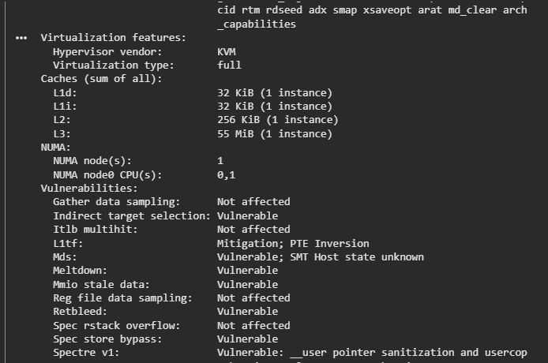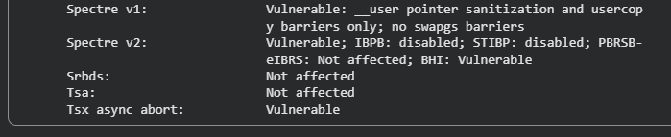

2.3 Performance Analysis
Speedup & Efficiency:
OpenMP shows speedup S < 1, with low efficiency because thread management overhead dominates the small loop computations. MPI achieves modest speedup (S ≈ 1) and its efficiency decreases as more processes are added due to communication costs. CUDA achieves a very high speedup (S ≈ 243) thanks to massive parallelism and highly optimized GPU execution.
Bottlenecks:
For OpenMP, the main bottleneck is thread creation and scheduling, which outweighs computation for small loops. MPI performance is limited by data distribution and synchronization overhead. CUDA’s main bottleneck is the memory transfer between host and GPU, though it is small relative to computation time for large matrices.
Scalability Limitations:
OpenMP is limited by the number of CPU cores and suffers for fine-grained tasks. MPI scalability is constrained by increasing communication overhead as the number of processes grows. CUDA scalability depends on GPU memory availability and optimal block/grid configuration for large matrices.
Overhead Analysis:
In OpenMP, minimal computational work per iteration suffers due to thread overhead. MPI incurs additional cost from scatter and broadcast operations. CUDA kernel launch overhead is negligible compared to the total computation, making it highly efficient for large workloads.

2.4 Critical Reflection
Challenges Encountered:
During implementation, OpenMP required careful handling of private and shared variables to avoid race conditions. MPI presented challenges in distributing data correctly and ensuring proper synchronization between processes. CUDA faced several challenges: driver/runtime version mismatches, unsupported PTX toolchain errors, GPU memory allocation issues, and careful memory management along with correct grid/block configuration to achieve optimal performance. Using Google Colab’s T4 GPU also required verifying CUDA toolkit compatibility and explicitly setting environment variables.
Limitations Restricting Scalability:
OpenMP is limited by the number of CPU cores and suffers when loop iterations are too small. MPI scalability is constrained by communication overhead, which increases with the number of processes. CUDA is limited by GPU memory capacity and block size configuration, which can affect performance for very large matrices. Additionally, CPU-based parallelism on Colab is limited to one physical core, so speedup may not be observable for OpenMP and MPI.
Potential Optimizations for Future Improvements:
OpenMP could benefit from loop unrolling or task-based parallelism to reduce overhead. MPI could use non-blocking communication to overlap computation and data transfer. CUDA performance can be enhanced using shared memory, memory coalescing, and optimized kernel configurations. Hybrid CPU-GPU parallelism is another potential improvement.
Lessons Learned:
This project reinforced the importance of selecting the right parallel paradigm based on problem size and hardware. Understanding overheads, data distribution, and memory hierarchy is critical. OpenMP is suitable for shared-memory systems, MPI excels in distributed systems, and CUDA achieves massive GPU speedups. Proper profiling, iterative tuning, and verifying software/hardware compatibility are essential for high-performance computing.
Graphs and performance evaluation results
OpenMP
Threads vs Time
Threads | Time (s)
1 | 1.831468
2 | 2.826709
4 | 2.455275
8 | 2.437010
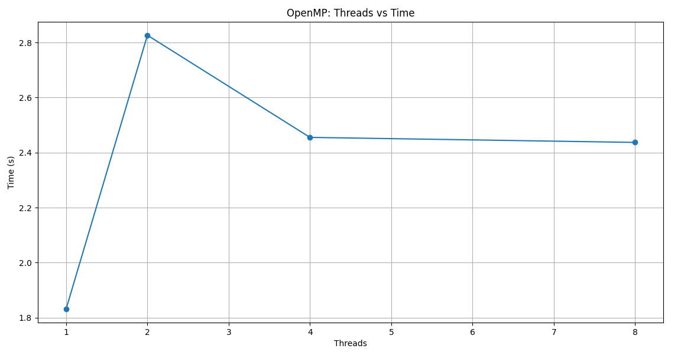
Threads vs Speedup
Speedup = Serial Time / Parallel Time, Serial = 1.043264 s
Threads | Speedup
1 | 0.57
2 | 0.37
4 | 0.43
8 | 0.43
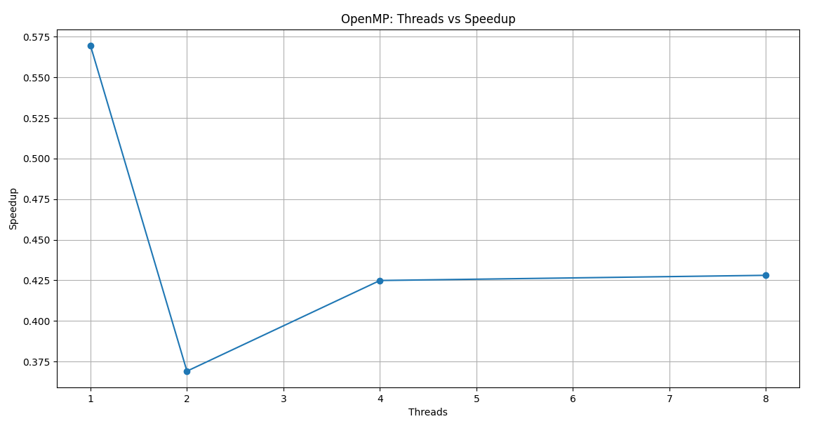
MPI
Processes vs Time
Processes | Time (s)
1 | 0.923679
2 | 1.192825
4 | 1.148780
8 | 0.946988
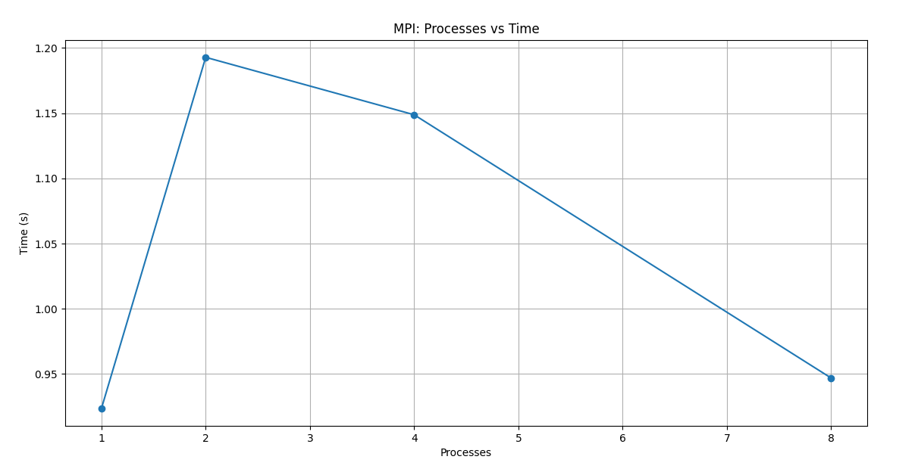
Processes vs Speedup
Speedup = Serial Time / Parallel Time, Serial = 1.043264 s
Processes | Speedup
1 | 1.13
2 | 0.87
4 | 0.91
8 | 1.10
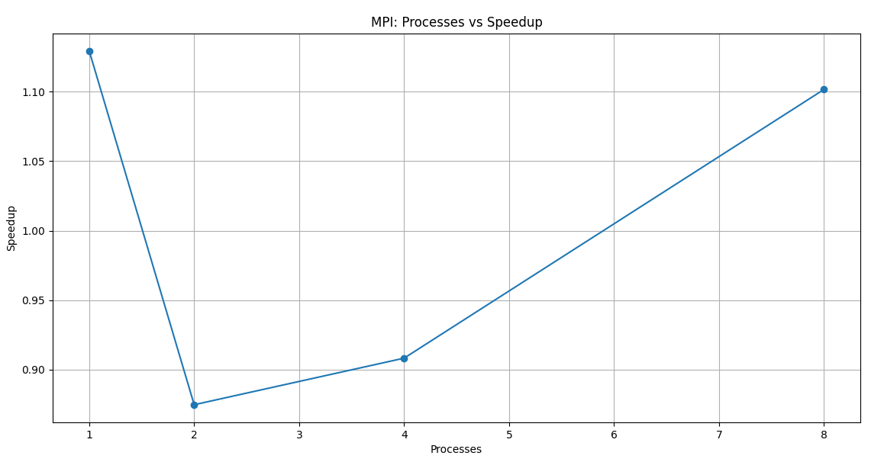
CUDA
Block Size vs Time
Block Size | Avg Time per Iteration (ms) | Time (s)
8×8 | 6.488 | 0.006488
16×16 | 4.440 | 0.004440
32×32 | 4.288 | 0.004288

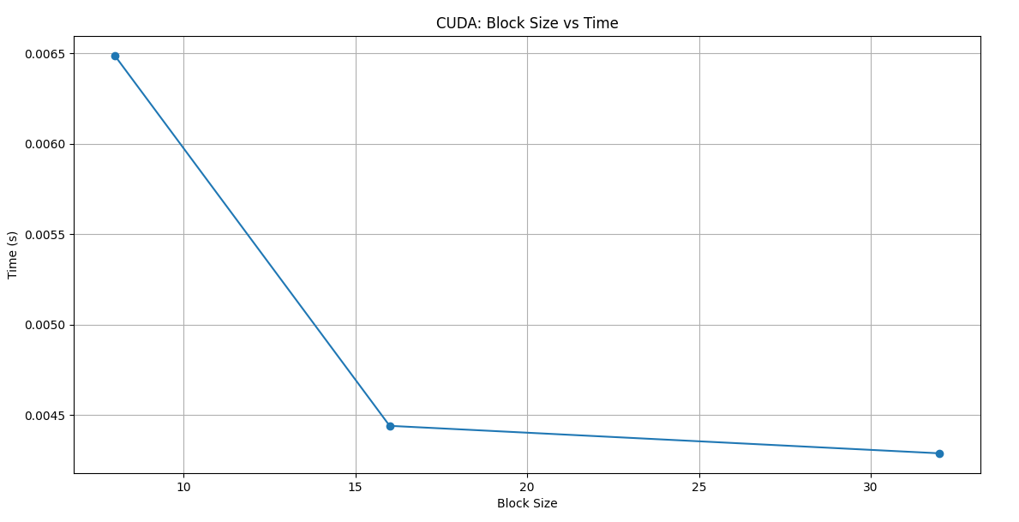
Block Size vs Speedup
Speedup = Serial Time / CUDA Time (Serial = 1.043264 s)
Block Size | Speedup
8×8 | 160.7
16×16 | 234.9
32×32 | 243.3
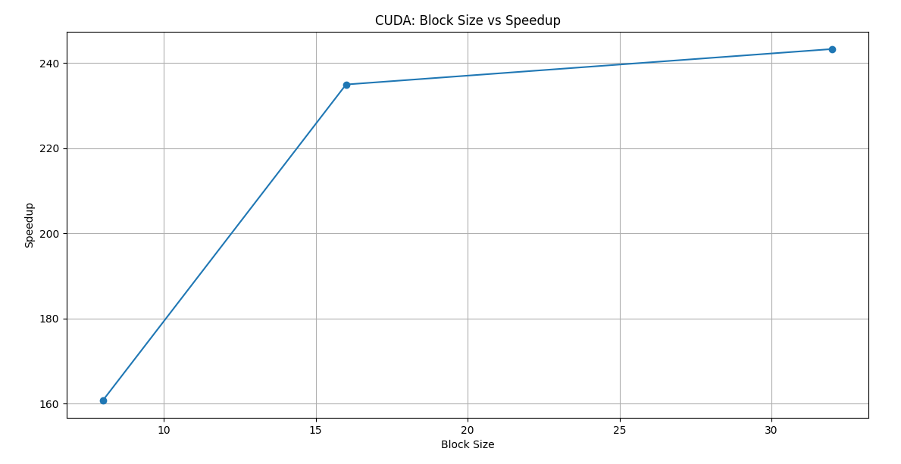
Comparative Table (Serial vs OpenMP vs MPI vs CUDA)
Method | Best Config | Time (s) | Speedup
Serial | N/A | 1.043264 | 1.0
OpenMP | 8 Threads | 2.437010 | 0.43
MPI | 1 Process | 0.923679 | 1.13
CUDA | 32×32 Blocks | 0.004288 | 243.3
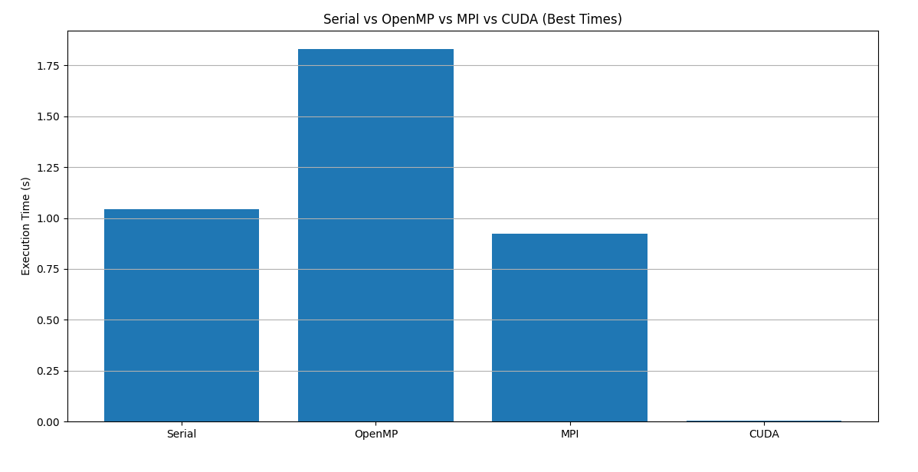

Speedup Comparison Across All
Method | Speedup
Serial | 1
OpenMP | 0.43
MPI | 1.13
CUDA | 243.3

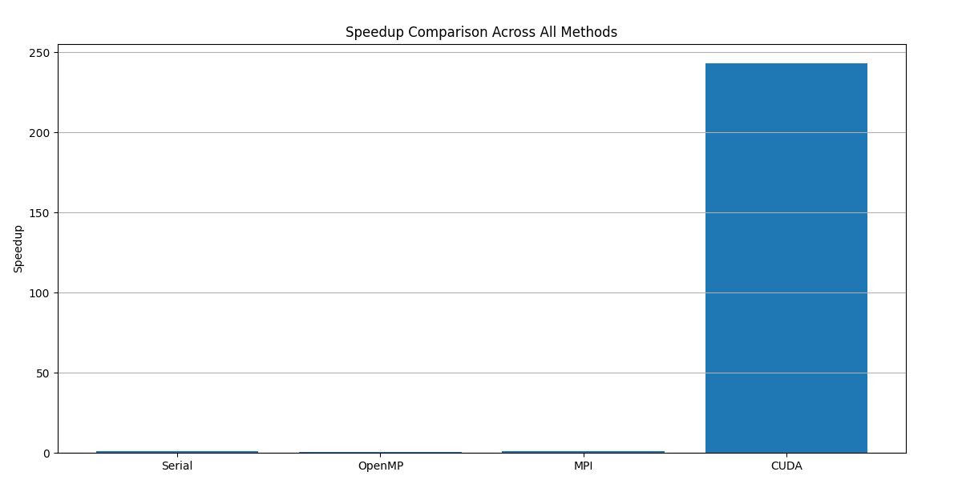
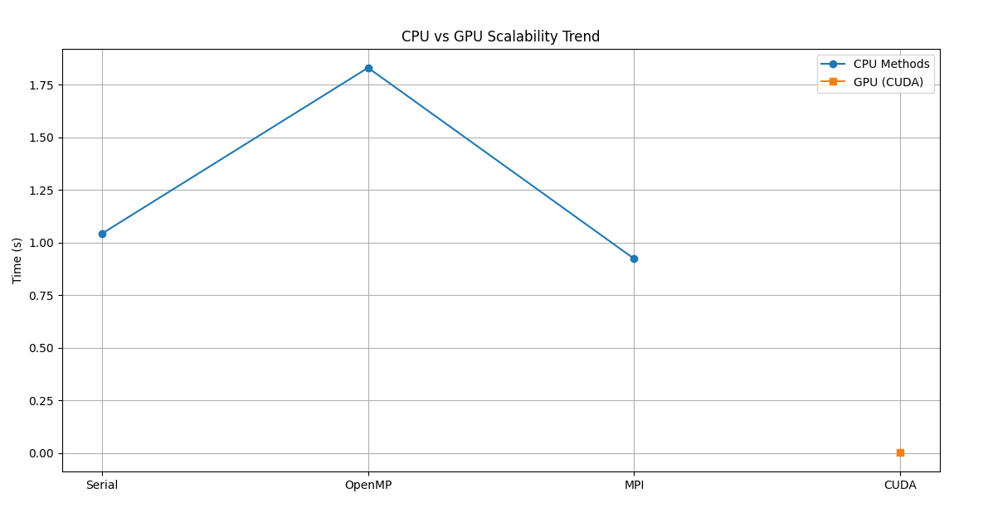
Comparison of Implementations
Implementation | Best Time (s) | Speedup | Notes
Serial | 1.043 | 1.0 | Baseline single-threaded execution
OpenMP | 2.437 | 0.43 | Nested loops parallelized using threads
MPI | 0.924 | 1.13 | Row-wise data distributed across processes
CUDA | 0.004288 | 243.3 | GPU parallelized, thousands of threads

OpenMP shows slower performance than serial due to overhead in thread management and nested loop granularity.MPI improves slightly for 1 process but does not scale efficiently due to communication overhead for small matrices.CUDA delivers massive speedup due to high parallelism on GPU and efficient memory usage.
Most Appropriate Implementation
If sufficient computational resources are available, CUDA is the most suitable implementation because it provides orders-of-magnitude speedup.
For CPU-only environments, MPI is better than OpenMP for distributing computation across multiple nodes.
Strengths and Weaknesses
Implementation | Strengths | Weaknesses
OpenMP | Easy to implement; good for loop-level parallelism | Poor scaling with small workloads; overhead dominates
MPI | Can scale across multiple nodes; flexible data distribution | Communication overhead; requires careful partitioning
CUDA | Extremely fast on GPU; large-scale parallelism | Requires GPU hardware; memory management is critical

References
[1] D. R. Chopra and P. P. Pande. “Compiler Optimization Techniques for OpenMP Programs.” ResearchGate. Available: https://www.researchgate.net/publication/2562696_Compiler_Optimization_Techniques_for_OpenMP_Programs [accessed Sep. 27, 2025].
[2] N. Joram. “Scatter and Gather in MPI.” Medium – Nerd For Tech. Available: https://medium.com/nerd-for-tech/scatter-and-gather-in-mpi-e66b69366ee3 [accessed Sep. 28, 2025].
[3] NVIDIA Developer Forums. “When to use Serial CPU, CUDA, OpenMP and MPI?” NVIDIA Developer. Available: https://forums.developer.nvidia.com/t/when-to-use-serial-cpu-cuda-openmp-and-mpi/48379 [accessed Sep. 26, 2025].
[4] QuantEcon. “parallelization.ipynb.” Google Colab Notebooks. Available: https://colab.research.google.com/github/QuantEcon/lecture-python-programming.notebooks/blob/master/parallelization.ipynb [accessed Sep. 28, 2025].

